FMS API

Document deployment guide

**Version :** 1.0

**Updated:** 26/11/2021

**Prepared by:** Dung Pham

# Table of Contents

### Table of Contents

1 Table of Contents 2

1.1.1 Table of Contents 2

2 Configuration Enviroment for development 3

2.1 Java Development Kit (JDK) 3

2.1.1 Install Java Development Kit (JDK) 3

2.1.2 Verify That the JDK Is Installed Correctly 3

2.2 Apache Tomcat 4

2.3 Install Postman plugin into your chrome 4

2.4 Setup Maven Home 5

2.4.1 Download Maven 5

2.4.2 Set Maven Home 6

2.5 Install IDE tool (Eclipse tool) 9

3 Deployment And Configuration 11

3.1 FMS Service API 11

3.1.1 Database configuration 11

3.1.2 Private key for authentication by DA 14

3.1.3 Configure ESB system service connection. 14

3.1.4 Configure file template’s path for report. 15

3.1.5 Configure param for data migration 17

3.1.6 Tomcat & Deployment 18

# Configuration Enviroment for development

This section defines the installation of the pre-requisite software for Back-end

## Java Development Kit (JDK)

This section describes the installation of the Java Development Kit. FMS API requires the JDK version 1.8 or higher.

### Install Java Development Kit (JDK)

Install the Java Development Kit, version 1.8.

1. Download a copy of the Java SE 8 Development Kit. Be sure to select the proper version to match your operating system.

<http://www.oracle.com/technetwork/java/javase/downloads/index.html>

1. Right click on the file and select **Run as administrator**.
2. During the installation, accept all the default values by pressing the **Next** button on all screens.
3. If applicable, ignore the product registration screen/page after the installation is complete.
4. Make a note of the folder where Java is installed.

### Verify That the JDK Is Installed Correctly

Verify that the Java JRE and JDK are installed correctly.

1. Open a DOS window.
2. Enter the following command:

java –version

You should see a message like the following (your version number or build number may vary):

java version "1.8.0_211"

Java(TM) SE Runtime Environment (build 1.8.0_211-b12)

Java HotSpot(TM) 64-Bit Server VM (build 25.211-b12, mixed mode)

1. Enter the following command:

javac –version

You should see a message like the following (your version number may vary):

javac 1.8.0_211

1. Verify that both messages show a Java version that starts with 1.8. If you do not see these messages, go back through the installation steps for the Java JDK.

## Apache Tomcat

Download the Apache Tomcat, such as, **apache-tomcat-9.0.46.zip** from the following location:

<https://tomcat.apache.org/download-90.cgi>

Unzip the file to a folder of your choice, such as *“…/app/fms/….”*

## Install Postman plugin into your chrome

With Postman, we can construct a HTTP request and test the API.

1. Open your Chrome browser, search the Postman plugin and add it into Chrome.

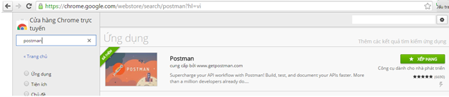

## Setup Maven Home

This section describes the setup maven home.

### Download Maven

Visit [Maven official website](https://maven.apache.org/download.cgi), download the Maven zip file, for example: apache-maven-3.6.0-bin.zip.

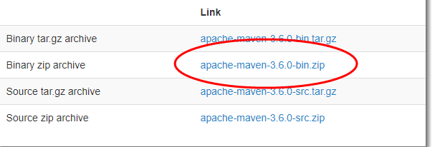

Unzip it to a folder. In this article, we are using c:\opt\apache-maven-3.6.0

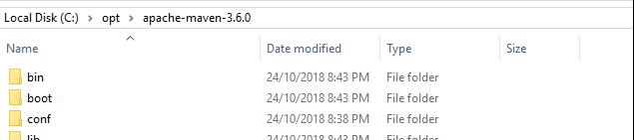

### Set Maven Home

Add a MAVEN_HOME system variable, and point it to the Maven folder. Press Windows key, type adva and clicks on the View advanced system settings

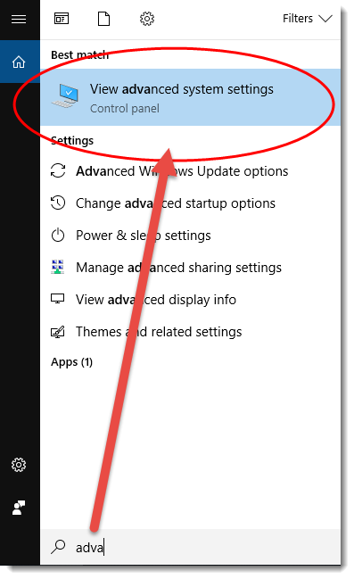

In System Properties dialog, select Advanced tab and clicks on the Environment Variables... button

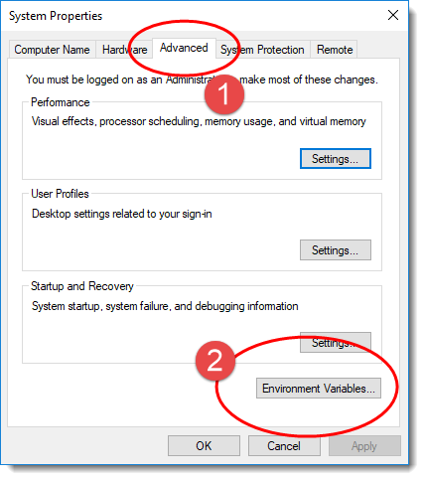

In “Environment variables” dialog, System variables, Clicks on the New... button and add a MAVEN_HOME variable and point it to c:\opt\apache-maven-3.6.0

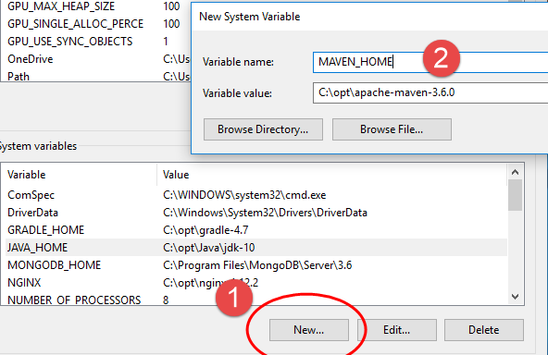

In system variables, find PATH, clicks on the Edit... button. In “Edit environment variable” dialog, clicks on the New button and add this %MAVEN_HOME%\bin

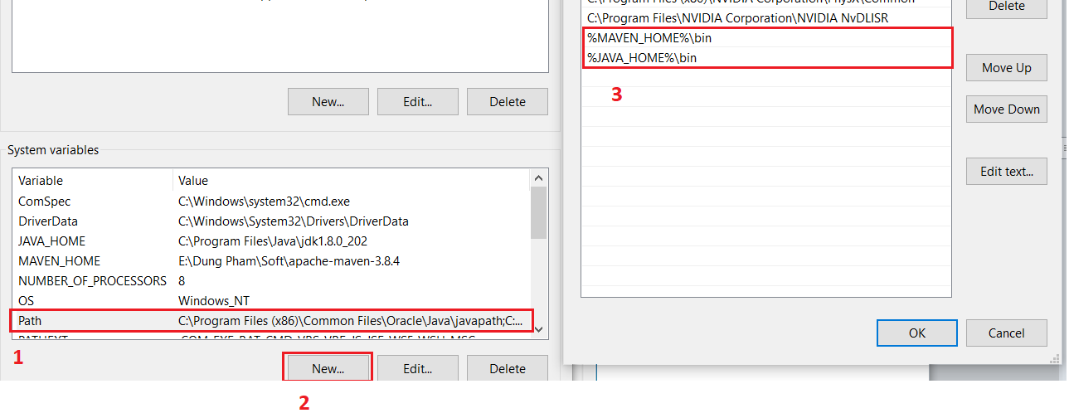

Done, start a new command prompt, type mvn –version

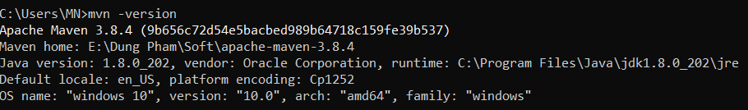

## Install IDE tool (Eclipse tool)

This section describes the setup maven home.

Download the Eclipse IDE tool, go to Eclipse official as link below.

<https://www.eclipse.org/downloads/>

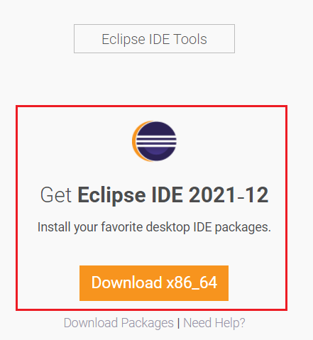

Install the Eclipse IDE for development.

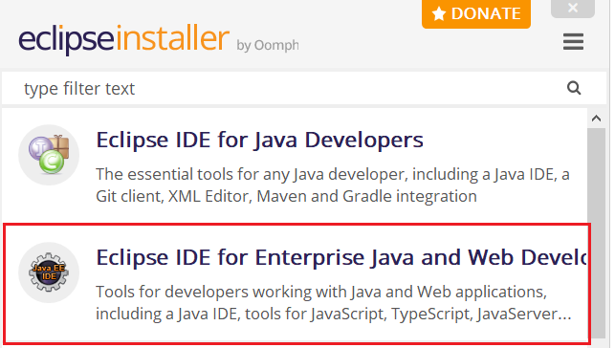

Then install.

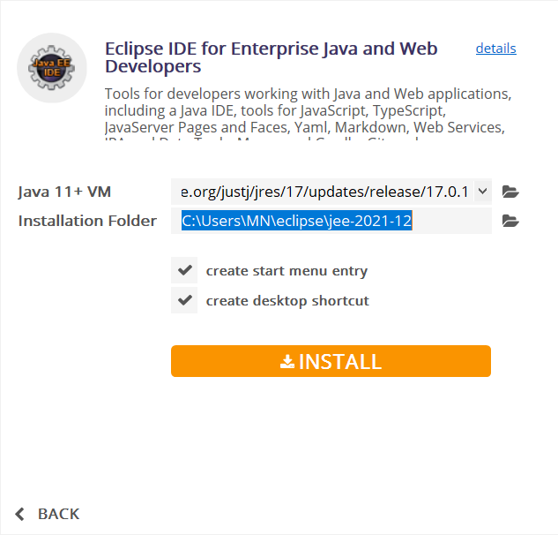

Done and launching.

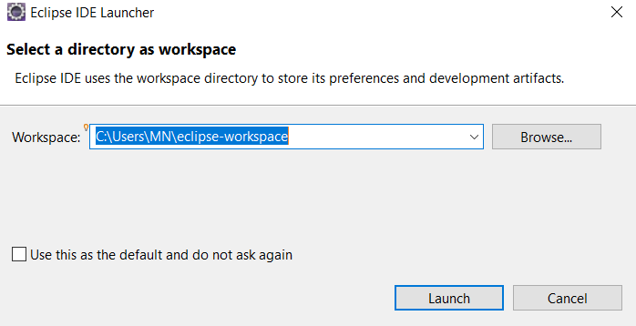

# Deployment And Configuration

This section defines the deployment & configuration system.

## FMS Service API

Get the war package at <https://git.shinhanfinance.com.vn/internal/fms-system/-/tree/develop/BE> *source* and put the **Web-app tomcat folder** then start the tomcat server.

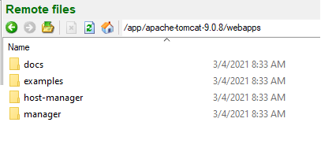

### Database configuration

This section defines the configuration database connection for FMS system.

1. In Tomcat directory, create new folder name “**fms-config**”.

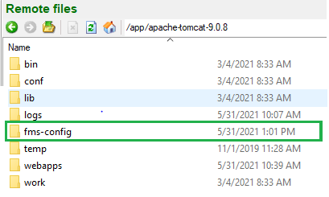

1. Create new file “**fms-config.properties**” into folder in step #1.

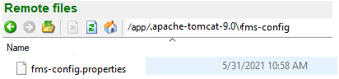

1. In Tomcat directory, create new folder name “**fms-config**”.

1. Create new file “**fms-config.properties**” into folder in step #1.

1. Open the properties then add the value as below.

**Oracle DB for FMS API**The configuration to connect FMS DB. Input the configuration to connect FMS database in below:

|  |  |  |
| --- | --- | --- |
| ## Oracle DB Data source. ## | | |
| Key | Value | Description |
| datasource.oracle.fms.url | jdbc:oracle:thin:  @//10.148.50.4:1521/DEVPDB.prudential.com | URL for New FMS schema |
| datasource.oracle.fms.driver-class-name | oracle.jdbc.driver.OracleDriver | Default value |
| datasource.oracle.fms.username |  | Username of New FMS schema |
| datasource.oracle.fms.password |  | Password of New FMS schema |
| datasource.oracle.fms.old.url | jdbc:oracle:thin:  @//10.148.50.4:1521/DEVPDB.prudential.com | URL for Old FMS schema |
| datasource.oracle.fms.old.driver-class-name | oracle.jdbc.driver.OracleDriver | Default value |
| datasource.oracle.fms.old.username |  | Username of Old FMS schema |
| datasource.oracle.fms.old.password |  | Password of Old FMS schema |

***Example:***

### Private key for authentication by DA

This section defines the private key to authenticate by user DA.

**Private key for authentication by DA**Configure private-key to authenticate DA user at “**fms-config.properties”** in path: ***{tomcat}/fms-config/*fms-config*.properties***.

|  |  |  |
| --- | --- | --- |
| ## Private key for authentication by DA. ## | | |
| Key | Value | Description |
| private_key_da_user | 1O34IVHOA89ZN4H6 (In Dev env) | ESB URL for create Notepad |

***Example:***



### Configure ESB system service connection.

This section defines the configuration for calling ESB API from FMS API.

**Configuration ESB API which called from FMS**

Configure ESB service connection at “**fms-config.properties”** in path: ***{tomcat}/fms-config/*fms-config*.properties***.

|  |  |  |
| --- | --- | --- |
| ## ESB Server Configuration. ## | | |
| Key | Value | Description |
| esb_api_url_create_notepad_service | <http://10.148.50.5:443/api> (In Dev env) | ESB URL for create Notepad |
| esb_api_url_comp_blacklist_service | <http://10.148.50.5:8098/api/core> (In Dev env) | ESB URL for update comp blacklist |
| esb_api_url_update_ais_agent_service | <http://10.148.50.5:8094/api> (In Dev env) | ESB URL for update agent AIS |
| esb_api_url_authentication_service | <http://10.148.50.5:8094/api> (In Dev env) | ESB URL for authenticate by DA account |
| esb_api_url_get_customer_service | <http://10.148.50.5:8094/api> (In Dev env) | ESB URL for get customer information |
| esb_api_url_get_queue_by_systemId | <http://10.148.50.5:8094/api> (In Dev env) | ESB URL for get queue information |

***Example:***

### Configure file template’s path for report.

This section defines the configuration directory to storage files in FMS.

**Create the folder to storage the FMS’s files**

* Create the {**baseDir**} directory as parent directory.
* Create the sub directory in below:
  + {baseDir}/fms/document
  + {baseDir}/fms/document/error
  + {baseDir}/fms/storage
  + {baseDir}/fms/esbData
  + {baseDir}/fms/template
  + {baseDir}/fms/export

*In dev environment, {****baseDir****} = “C:/Dung Pham/Project/FMS/Imp”.*

**Get template report for FMS API**

Get those files “<https://git.shinhanfinance.com.vn/internal/fms-system/-/tree/develop/BE/template>” on GitSvn then move all files to **template folder** **{baseDir}/fms/esbData**.

**Configure the directory folder for FMS API**

Configure folder loading resource template at “**fms-config.properties”** in path: ***{tomcat}/fms-config/*fms-config*.properties***.

|  |  |  |
| --- | --- | --- |
| ## Template Folder Configuration. ## | | |
| Key | Value | Description |
| PATH_FMS_DOCUMENT_FOLDER | {baseDir}/fms/document | This folder to storage document file which user attached |
| PATH_FMS_DOCUMENT_ERROR_FOLDER | {baseDir}/fms/document/error | This folder to storage files which migrate data error. |
| PATH_FMS_STORAGE_FOLDER | {baseDir}/fms/storage | This folder to storage the “description” file which user storage |
| PATH_ESB_DATA_TEMP_FOLDER | {baseDir}/fms/esbData | This folder to storage data which populate from ESB (Queue data) |
| PATH_TEMPLATE_FOR_EXPORT_DATA | {baseDir}/fms/template/ | This folder contains the template for export report |
| PATH_EXPORT_FMS | {baseDir}/fms/export/ | This folder to storage files which user export report |

***Example:***

### Configure param for data migration

This section defines the configuration the migration data from Old and New FMS System.

**Configure the running migration batch job**

Configure folder loading resource template at “**fms-config.properties”** in path: ***{tomcat}/fms-config/*fms-config*.properties***.

|  |  |  |
| --- | --- | --- |
| ## Data Migration Configuration. ## | | |
| Key | Value | Description |
| fms.migrate.allow | NO | YES | NO = Don’t allow data migration.  YES = Allow data migration. |
| fms.migrate.url.get.document | http://10.148.50.34 | URL to get document of OLD FMS. |
| fms.migrate.fileName.default.document |  | Should be ‘’ (blank) |
| fms.migrate.url.save.document | {fmsURL}/{contextPath}/shinhan/common/document/  Note in dev:  {fmsURL} = <http://10.148.84.246:9191>  {contextPath} = /fms-api | The API of new FMS to save document file from old FMS. |

***Example:***

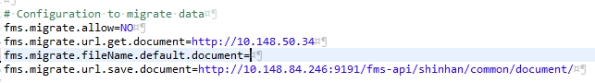

### Tomcat & Deployment

1. Direct the path to “***{tomcat}****/bin”*, typing **startup.bat** to start/restart the Tomcat.  
   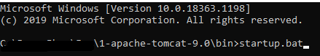
2. Check the Tomcat started successfully.  
   